Interdisciplinary Dataset on the Fracture Network of the Tromm Granite, Southern Odenwald, SW Germany
Authors: Matthis Frey, Claire Bossennec, Lukas Seib, Kristian Bär, Ingo Sass

Description
This data publication is a supplement to the paper by Frey et al. (2021, in prep.), which describes the interdisciplinary and multi-scale characterization of the fracture network in the Tromm Granite.
The crystalline basement in the Upper Rhine Graben (URG) represents an attractive reservoir for deep geothermal projects due to the comparatively high temperatures and the abundance of large-scale faults and fractures. A spatially resolved description of the fracture network, which strongly influences the hydraulic properties in the subsurface, is crucial for reducing exploration risks. However, only a few wells were drilled into the basement of the URG and image logs are sparse and often not openly accessible, causing considerable uncertainties. To circumvent this problem, a multidisciplinary outcrop analogue study was performed in the Tromm Granite, located in the southern Odenwald. Using a LiDAR scanner, comprehensive structural geological datasets were collected in five abandoned quarries and evaluated both automatically and manually. This dataset was extended by a regional lineament analysis based on two digital elevation models with 1 m and 1 arcsecond resolution. This allows a comprehensive description of the fracture network in the Tromm Granite regarding the density, length, orientation and connectivity of fractures. Discrete fracture network (DFN) models were developed for two outcrops and the equivalent permeability tensors under reservoir conditions were calculated. Thereby, the influence of different parameters, such as fracture orientation, density, aperture and mineralization was investigated.
In addition to the classical structural geological data, geophysical measurements were carried out to allow a refined identification of the naturally permeable zones. Along 11 profiles, 431 gravity measurements were performed and a complete Bouguer correction with a reference density of 2670 kg/m³ was applied. Together with existing gravity field data from LIAG, HVBG, LVermGeo and LGL, an extended Bouguer anomaly map was interpolated. By applying high-pass filters, the regional part of the gravity field was subtracted. Stochastic inversion of the anomaly yields a 3D density model of the subsurface down to 2 km depth, from which fracture porosity can be inferred. In addition, concentration measurements of radon activity were made along one profile. Areas of elevated concentration indicate the existence of permeable faults or fracture corridors. In particular, combining radon measurements with other methods, such as gravity, provides an more accurate estimate of subsurface porosity and permeability.
Figure 1 summarizes all locations in the Tromm Granites where structural and geophysical data were collected.
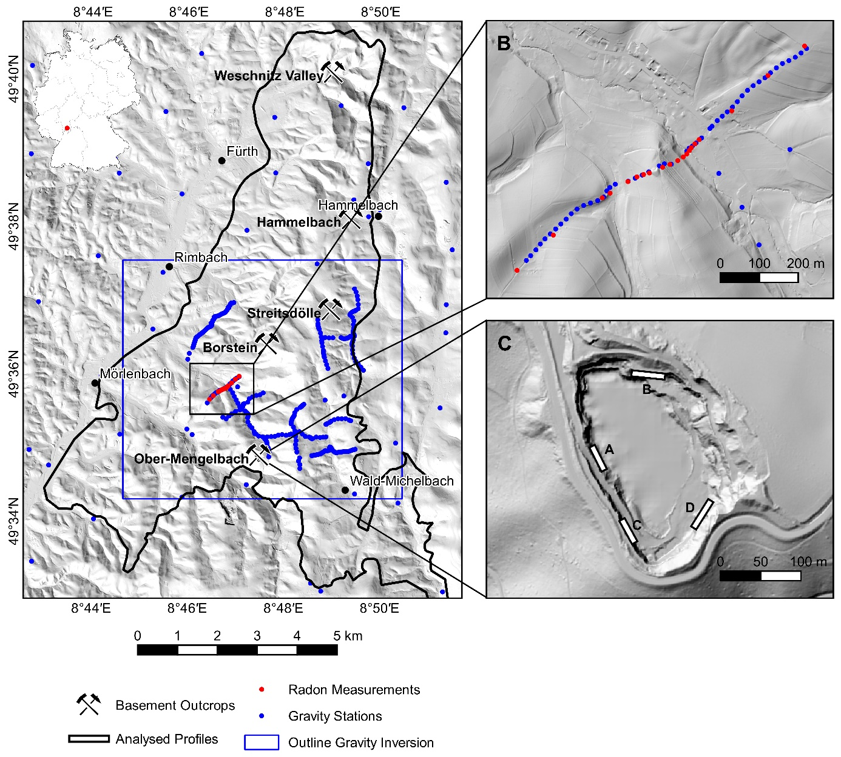
Fig. 1: Summary of the investigations conducted in the Tromm area (modified after Frey et al., 2021 in prep.): (A) overview of the locations where structural and geophysical data were acquired; (B) detailed view of the gravity and radon profile; (C) detailed view of the quarry in Ober-Mengelbach with location of profiles, which have been manually interpreted.

Enclosed files
- Excel file that summarizes the outcrop and lineament analyses
- Image files, that illustrate the manually interpreted outcrop walls (in a zip-folder)
- CSV file containing the processed gravity data
- Grid files of the interpolated and filtered gravity anomalies (in a zip-folder)
- CSV file of the gravity inversion results
- CSV file containing the radon concentration data

Reference
Frey, M.; Bossennec, C.; Seib, L.; Bär, K.; Sass, I. (2021 in prep.): Interdisciplinary Characterization of Fracture Networks in the Crystalline Basement: A case study from the Southern Odenwald, SW Germany

