Geochemical, petrophysical and petrographical dataset of fractured Variscan granites of the Cornubian Batholith, SW United Kingdom
Aysegul Turan¹, Kristian Bär², Claire Bossennec³, Ingo Sass^{1,3}
¹Geothermal Science and Technology, Institute of Applied Geosciences, Technical University of Darmstadt, Darmstadt, 64287, Germany
²Geothermal Engineering GmbH, an der RaumFabrik 33c, 76227 Karlsruhe, Germany
³Helmholtz Centre Potsdam – GFZ German Research Centre for Geosciences, Section 4.8 – Geoenergy, Telegrafenberg, 14473, Potsdam, Germany
Correspondence: Aysegul Turan (turan@geo.tu-darmstadt.de)

Outcrop analogue studies are of high priority as they allow the interpretation of geophysical surveys, minimizing the exploration risk, reliable predictions of reservoir properties and drawing conclusions on expected discharge, before drilling in a cost-wise way. Detailed knowledge of the petrophysical properties and petrographical characteristics of potential reservoir rocks improve the interpretation of forthcoming borehole logging and of fluid flow in different zones. Built datasets yet comprise the development of the necessary input for static and dynamic reservoir model parametrization.
In the framework of EU H2020 funded ‘MEET’ project (‘Multidisciplinary and multi-context demonstration of EGS exploration and Exploitation Techniques and potentials’, grant agreement no:792037) outcrop analogue samples from the Cornubian Batholith, located in SW United Kingdom, were taken from the onshore plutons namely Land’s End, Tregonning-Godolphin, Carnmenellis, Carn Brea, Carn Marth and St. Austell. 47 granitic samples were collected from 23 outcrops representative for fresh, weathered, hydrothermally altered, fractured and faulted granites. From the outcrop samples, 338 cores with different diameters were obtained and the measurements of grain density, bulk density, permeability, porosity, acoustic wave velocity, thermal conductivity, thermal diffusivity, magnetic susceptibility, uniaxial compressive strength, Poisson’s ratio, Young’s modulus, tensile strength, shear strength, cohesion, coefficient of friction and shear modulus were performed on oven-dried cores under ambient temperature and atmospheric pressure in the HydroThermikum laboratory of the Technical University of Darmstadt. Petrographical and geochemical characterization were done for 47 outcrop analogue samples and for the drill cuttings, taken between 3,980 and 5,275 m (measured depth) in UD1; the production well of United Downs Deep Geothermal Power Project, first commercial deep geothermal project of UK, through thin section analysis, X-ray diffraction (XRD) and X-ray fluorescence (XRF).
This dataset presents the geochemical, petrophysical and petrographical properties of Early Permian aged fractured Variscan granite specifically not overprinted by any younger tectonic regime. It forms a basis to other publications, where the results of the aforementioned multiparameter rock characterization are discussed in detail and are used for stochastic regional resource assessment, respectively. It follows the same database structure as PetroPhysical Property Database (P³) of Bär et al. (2020). Each analyzed core is provided with a sample ID according to the naming convention within MEET project as ‘MEETCW001001001’ (Project name - region name - location number - sample number - core number).
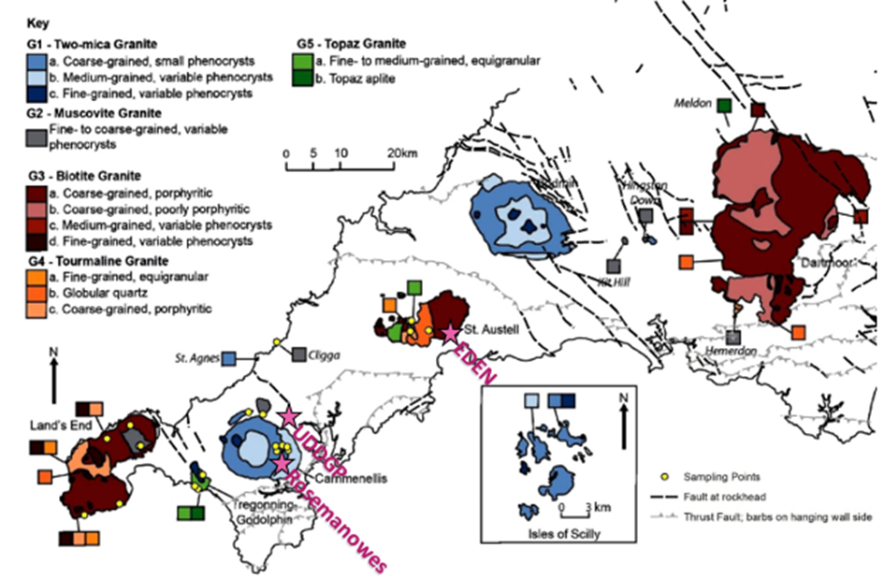
Figure 1: Map of MEET sampling points (shown as yellow dots) with respect to location of geothermal projects (shown as pink stars) (geology map modified after BGS (2007) and granite classification modified after Simons et al. 2016).
Acknowledgement and Funding
This work was done in the framework of the MEET EU project which has received funding from the European Union’s Horizon 2020 research and innovation program under grant agreement No 792037. The authors would like to thank MSc. Katja Schulz for her contribution in the field work, student assistant Thomas Busley for his help in sample preparation, MSc. Xenia Kirschstein for her help in sample preparation and lab measurements and student assistants Ariane Djahansouzi and Fatih Ekinci for their help in lab measurements. The authors are also thankful to BSc. student Lorenzo Casanova and MSc. student Christian Freundt for their contribution through their research as part of this study. Staff of Institute of Applied Geosciences at Technical University of Darmstadt; Georg Wasmer, Rainer Seehaus, Reimund Rosmann, Gabriela Schubert are gratefully acknowledged as well as Dr. Dirk Scheuvens for his help in sample description and XRF measurements and Dr. Rainer Petschick from Goethe University of Frankfurt for the support with the XRD measurements.
References
Bär, Kristian; Reinsch, Thomas; Bott, Judith (2020): The PetroPhysical Property Database (P³) – a global compilation of lab-measured rock properties. Earth Syst. Sci. Data 12 (4), 2485–2515. https://doi.org/10.5194/essd-12-2485-2020
Simons, B., Shail, R., Andersen, J. (2016): The petrogenesis of the Early Permian Variscan granites of the Cornubian Batholith: Lower plate post-collisional peraluminous magmatism in the Rhenohercynian Zone of SW England. Lithos (260), 76-94. https://doi.org/10.1016/j.lithos.2016.05.010
British Geological Survey (2007): BGS Geology 625k | DiGMapGB-625: Digital Geology Data.

