The ⁵⁷Fe-enriched Ni₃⁵⁷Fe/C catalyst has structural, morphological, and compositional properties close to the Ni₃Fe/C described earlier [1-3]. The layers of the catalyst drop-cast from a water/isopropanol-based suspensions form porous layers as seen in the SEM image in Figure S1(a). From the Z-contrast of the SEM images collected by means of the ESB detectors (Figure S1(b)) one can see that the catalyst is mainly composed of metallic nanoparticles homogeneously (at the microscopic level) distributed on the surface of carbon. Based on the statistical analysis of the TEM images (ca. 1000 particles), the main particle population falls into the particle diameter range of 10-30 nm (Figure S2). The particles are mainly covered by a layer of oxide (Figure S2) with the thickness up to 4 nm. Nevertheless, as it will be shown in the electrochemical measurements, the oxide layer does not fully passivate the metallic surface of the catalyst. Within the single particles or agglomerates or particles, the nickel and iron atoms show homogeneous co-distribution as evidenced by STEM-EDS imaging of the catalyst (Figure S3). According to the quantitative EDS analysis (Figure S4), ca. 50 wt% of the catalyst consist of carbon, the weight and molar Ni/Fe ratios span between 2.6 and 2.8 (expected 3). Based on the high molar concentration of oxygen (7.4 at%), one can conclude that Ni and/or Fe might be partially oxidized. Based on the XPS data (Figure S5), the catalyst is composed of carbon (82.5 at. %), oxygen (11.8 t.%), nickel (2.8 at. %, ca. 18 % of which is zero-valent Ni), iron (0.4 at. %, which is fully oxidized), boron (1.9 at.%, mainly in the form of oxide and partially as boride), and silicon as an impurity.

[1] https://www.mdpi.com/2073-4344/8/10/454
[2] https://pubs.acs.org/doi/abs/10.1021/acscatal.9b01582
[3] https://pubs.acs.org/doi/full/10.1021/acsaem.0c03157

Figure 1S(a). SEM image (Ultra Zeiss, 4 kV) of the Ni₃⁵⁷Fe/C catalyst. InLens detector.
Figure 1a. SEM image (Ultra Zeiss, 4 kV) of the Ni₃⁵⁷Fe/C catalyst. ESB detector: brighter pixels correspond to the heavier elements.
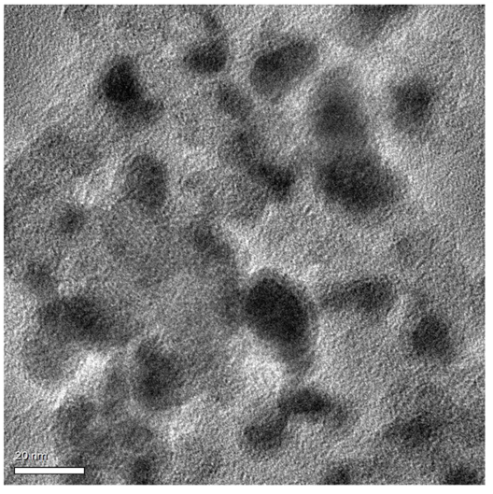
Figure S2. TEM image of the Ni₃⁵⁷Fe/C catalyst. Bar 20 nm. Accelerating voltage 200 kV.

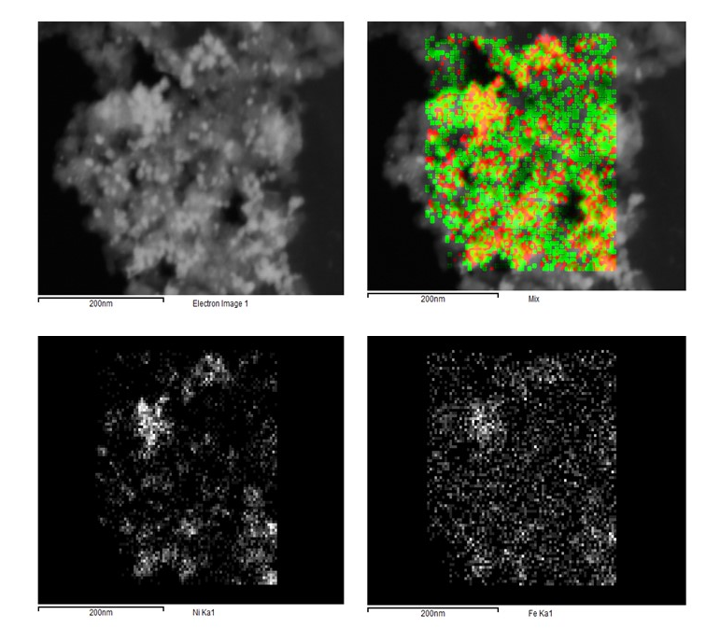
Figure S3. STEM-EDS imaging (Ultra Zeiss, 12 kV). Element mapping for the 50%Ni₃⁵⁷Fe/C sample. Scale
bar 200 nm. Red - Ni, green - Fe, yellow -overlapping of Ni and Fe.

Energy dispersive X-ray spectroscopy (EDS) and element maps were collected on a Zeiss Ultra-Plus high-resolution scanning electron microscope (HR-SEM). The EDS spectra were collected at an accelerating voltage of 10 kV with the data collecting time of 150 s. The STEM elemental mapping was performed with an acceleration voltage of 20 kV with the samples dispersed on holey carbon 200 mesh Cu TEM grids (Agar Scientific).

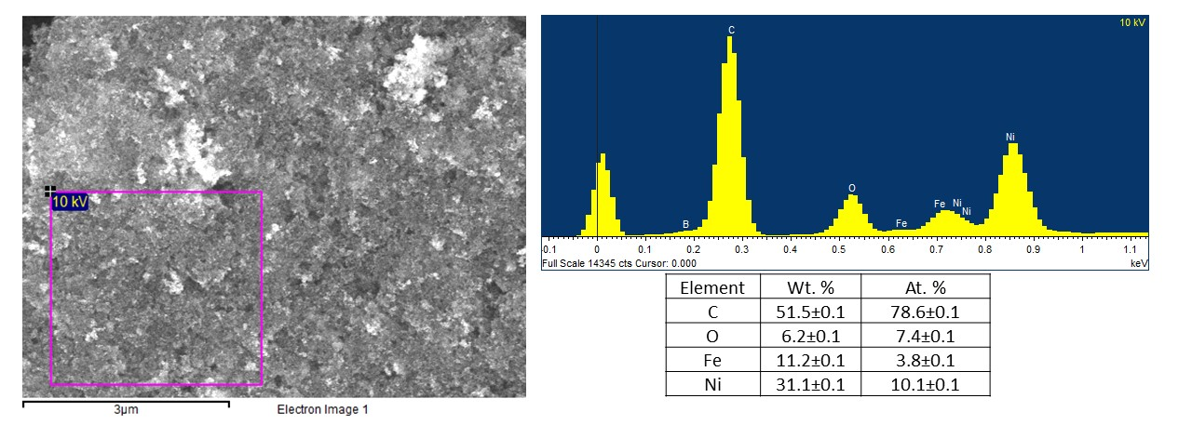
Figure S4. The low-resolution SE< image of the large area, where the EDS spectrum was collected to characterize the average chemical composition (see in the inserted Table) of the 50%Ni₃⁵⁷Fe/C sample.

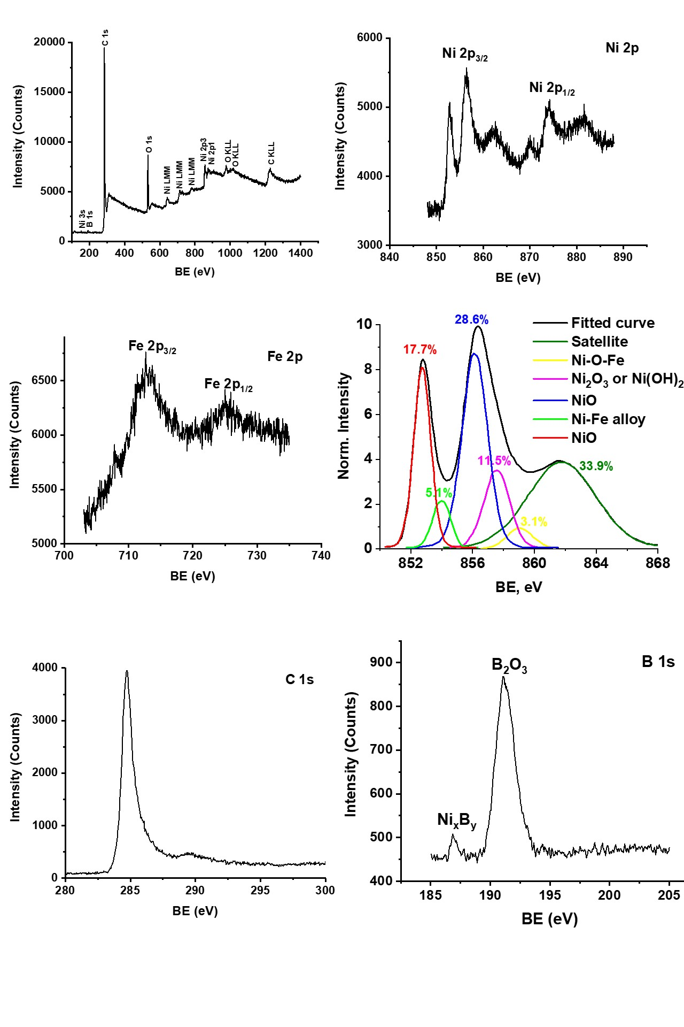
Figure S5. High-resolution XPS data for the 50%Ni₃⁵⁷Fe/C sample, including the detailed deconvolution of Ni 2p lines.
XPS measurements were performed in ultra-high 2.5 × 10⁻¹⁰ Torr base pressure) using a 5600 Multi-Technique System (PHI, Chanhassen, MN, USA). The samples were irradiated with an AlK_{α} monochromated source (1486.6 eV) and the outcome electrons were analyzed by a Spherical Capacitor Analyzer using a slit aperture of 0.8 mm. Survey spectra were registered in a wide energy range (0–1400 eV) at a low resolution. Utility multiplex spectra were taken for different peaks in a low energy range window at an intermediate (utility) resolution. Atomic concentration was calculated for all the elements present. Atomic concentration calculation accuracy was ±2, ±5, ±10 and ±20% for atomic concentrations around 50%, 20%, 5% and 1%, respectively.

Figure S6. XRD pattern for the 50%Ni₃⁵⁷Fe/C sample.
XRD data were collected using Rigaku Smartlab diffractometer with Cu X-ray source (λ = 1.5406 Å). XRD patterns were recorded in medium resolution parallel beam geometry at the tube current of 100 mA and tube voltage of 35 kV in θ/2θ scan mode with the scan rate of 1 deg. min⁻¹ and step0.01 deg. The structural data were compared to the ICDD database.

