Geological-geothermal 3D model of the Cenozoic graben fill of the northern Upper Rhine Graben, Germany

Meike Hintze1,2, Kristian Bär1,3, Judith Bott4, Ingo Sass1,4,5

1Geothermal Science and Technology, Institute of Applied Geosciences, Technical University of Darmstadt, Darmstadt, Schnittspahnstrasse 9, 64287 Darmstadt, Germany

2???

3Geothermal Engineering GmbH, An der RaumFabrik 33c, 76227 Karlsruhe, Germany

4GFZ German Research Centre for Geosciences, Potsdam, Germany

5Darmstadt Graduate School of Excellence Energy Science and Engineering, Technical University of Darmstadt, Darmstadt, Germany

*Correspondence to*: Kristian Bär (baer@geo.tu-darmstadt.de)

# Licence

# Creative Commons Attribution 4.0 International License (CC BY 4.0)

# Citation

**When using the data please cite:**

Hintze, M.; Bär, K.; Bott, J.; Sass, I. (2022): *Geological-geothermal 3D model of the Cenozoic graben fill of the northern Upper Rhine Graben, Germany*. TUDatalib. <https://doi.org/XXXX>

**The data are supplementary material to:**

Bär, K.; Hintze, M.; Bott, J.; Sass, I. (2022): *3D model based assessment of the hydrothermal potential of the Pechelbronn Group in the northern Upper rhine Graben, Germany*. Energy. https://doi.org/XXXX

# Extended Abstract

This data publication is part of the Hessen 3D 2.0 joint research project, funded by the German ministry of Economics and Energy (Bundesministerium für Wirtschaft und Energie, BMWi) and provides a geological-geothermal 3D model of the Neogene and Paleogene graben fill of the northern URG. This model was used for the assessment of potential reservoir horizons for direct heat use and heat storage via hydrothermal well doublets. The primary target of this model is the assessment of the hydrothermal potential of the Pechelbronn Group for direct heat use. To locate potential exploration target areas, a 3D structural model of the northern URG is built (Figure 1). The Pechelbronn Group represents one model unit and is parametrized with statistically evaluated rock and reservoir properties. The other model units are from bottom to top: the Froidefontaine Subgroup, the Elsaß Subgroup, the Worms Subgroup and the Ried-Group (Figure 2, 3 and 4). Additionally, the faults are compiled into one set of surfaces (Figure 5).

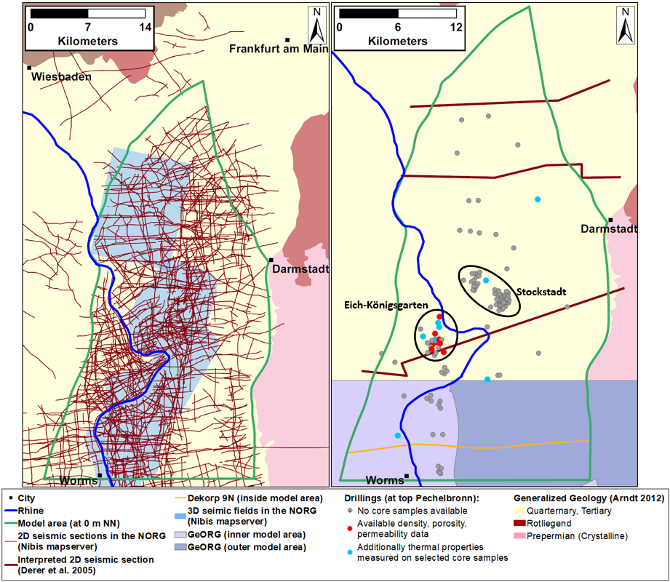

Figure 1: Left: 2D seismic sections and 3D seismic fields from oil, gas and geothermal exploration in the northern URG (Nibis mapserver 2020); most of the data is not publicly available. Right; Input data used for the 3D model. Location of boreholes (grey circles, including 16 boreholes with porosity and permeability data (red and blue circles), from which eight boreholes were chosen for further petrophysical analyses (blue circles)) and location of published interpreted seismic sections (Derer et al. 2005) and the reprocessed and reinterpreted DEKORP 9N section (Homuth et al. 2021).

As first step, the 3D structural model is built based on well and literature data, including published 2D seismic lines (Derer, 2003, Homuth et al. 2021), isoline maps from 3D seismic data interpretations (Aretz 2015, Perner 2018), geological cross sections and structural maps (Plein 1992, Doebl, 1967, Doebl and Olbrecht, 1974, Rheinhold et al. 2016) (dataset 1). The second step is the parametrization of the model units based on statistically evaluated petrophysical properties (grain and bulk density, porosity, permeability, thermal conductivity, thermal diffusivity, and specific heat capacity) measured on core samples from deep wells (dataset 2) and temperature data (continuous undisturbed and disturbed temperature logs, bottom hole temperatures (BHT) and production tests) measured in the open hole (Bär 2012) (dataset 3).

The most valuable type of input data for the construction of the top and base horizons of the Pechelbronn Group are lithological well logs of 112 boreholes (locations shown in Figure 1, number of wells for other model units given in Figure 2) from well log databases of the geological survey of Hesse and Lower Saxony (HLNUG and LBEG, respectively). In the southern part of the model area, the reprocessed and reinterpreted reflection seismic profile DEKORP 9N was included (Homuth et al. 2021, Figure 1). Faults were partly adopted from the 3D structural model by Arndt (2012) and from structural maps of Perner (2018), Derer (2003), Illies (1974) and modified where necessary to fit the well data. The southern part of the model area overlaps with a 3D model of the southern and central Upper Rhine Graben (GeORG-Projektteam 2013) and faults and horizons were fitted to the equivalent surfaces of this GeORG 3D model when not contradictory to well data or the new interpretation of DEKORP 9N.

The Pechelbronn Group is not further subdivided in the 3D model, because lithological well logs rarely yield detailed sufficient stratigraphic information on the subdivision into the main groups and subgroups.



Figure 2: Lithostratigraphic table of the northern Upper Rhine Graben with overview of the model horizons of the Hessen 3D 2.0 NORG model (green lines) compared with the old lithostratigraphic designations of the KW boreholes (after Straub 1962 and Schad 1964), the stratigraphic units defined by Grimm (2005) and Grimm et al. (2011) defined stratigraphic units, the horizons interpreted in the DEKORP-9N profile (green arrows), and the number of stratigraphic markers that could be extracted from the drilling profiles. (modified after Bär 2012 and Perner 2018).

The 3D structural model was built using the software tool Paradigm SKUA-GOCADTM 2018. Fault and horizon surfaces were constructed manually, without a predesigned workflow. The model extends 49 km in north-south and 27.5 km in west-east direction and down to a depth of 6 km. The mesh of the triangulated surfaces is irregular with finer mesh sizes in regions with higher input data density and coarser mesh elsewhere. A 3D stratigraphic grid (SGrid) was only constructed for the Pechelbronn Group with the GOCAD workflow 3D Reservoir Grid Building (Paradigm 2013b) and not for the other model units. The rectangular grid cells have a dimension of 25 m in horizontal and a maximum of 12.5 m in vertical direction, while the minimum thickness is adapted to the minimum thickness of the formation. The 3D model consists of roughly 110 million cells with cell volumes ranging from 4.9 to 21,883 m³ (median 1,414 m³).

In most parts of the study area, the Pechelbronn Group covers the Permocarboniferous Rotliegend discordantly, except for few locations, e.g., the northwestern part of the study area, where the Eocene clay is preserved and the southern part of the study area, where the Buntsandstein is preserved. The thickness of the Pechelbronn Group in the 3D model varies between 0.7 and 668 m (Figure 5). Locally there are areas where the Pechelbronn Group was eroded or not deposited (Reinhold et al. 2016, Kött and Kracht 2010). To have continuous top and bottom surfaces (apart from faults that cut the surfaces), the lithological well logs of drillings, that do not penetrate the Pechelbronn Group but go directly into the Rotliegend deposits, were modified slightly to yield Pechelbronn thicknesses just above 0 m (< 2 m). Small thicknesses (< 25 m) coincide with the geographical position of the structural high (Pfälzer-Stockstädter-Schwellenzone) between a northern and a southern paleo depositional basin called Rüsselsheimer Becken (north) and Mannheimer Bucht (south) mentioned by Grimm and Grimm (2003) and Derer (2003) and Derer et al. (2003, 2005). Larger thicknesses can be found in the southwestern part of the study area, especially in the vicinity of faults, and in the northwestern part in the surroundings of Groß Gerau where the Pechelbronn Group was found with a thickness of roughly 500 m in a geothermal exploration drilling (Reinecker, personal communication). Whether these deposits are entirely part of the Pechelbronn Group or rather remnants of the Upper Permocarboniferous Rotliegend is still under debate (Kiefer et al. 2020).

The depth below surface ranges between 1225 and 3465 m as shown in Figure 4. Larger depths are found in the northwestern and southeastern study area. Shallower depths are found in the southwest, between the western boundary fault and the first inner graben normal fault. In the northeast along the fault plane of the northern master fault depths are shallow and thicknesses low.

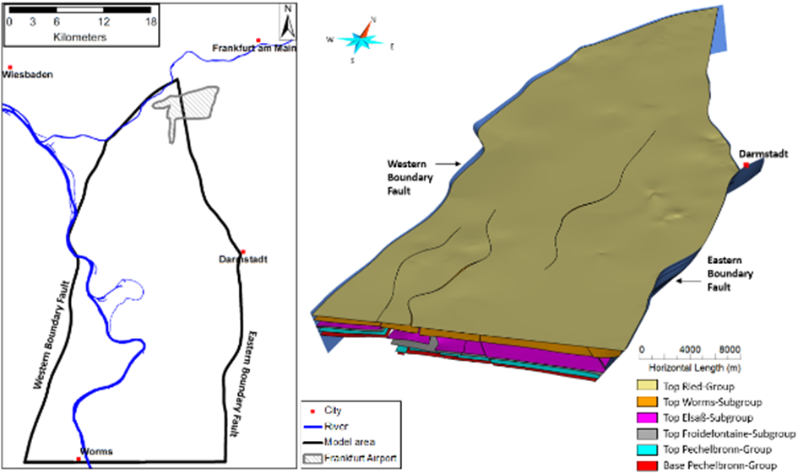

Figure 3: Position of the model area (left) and overview of model horizons (right)

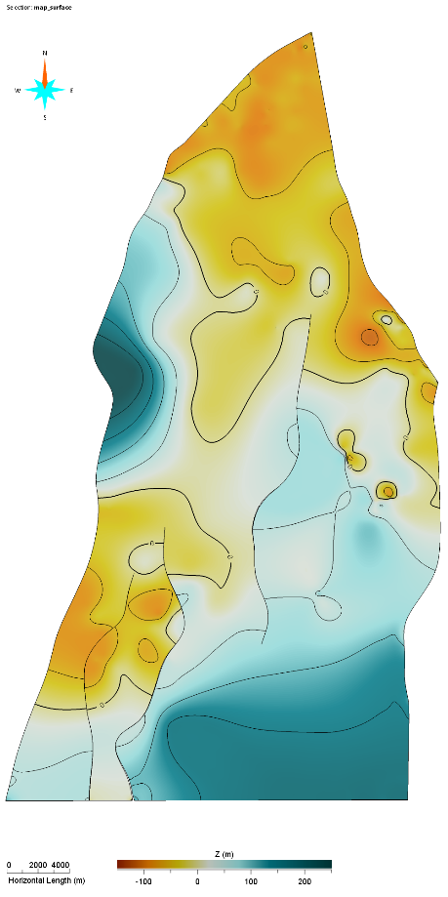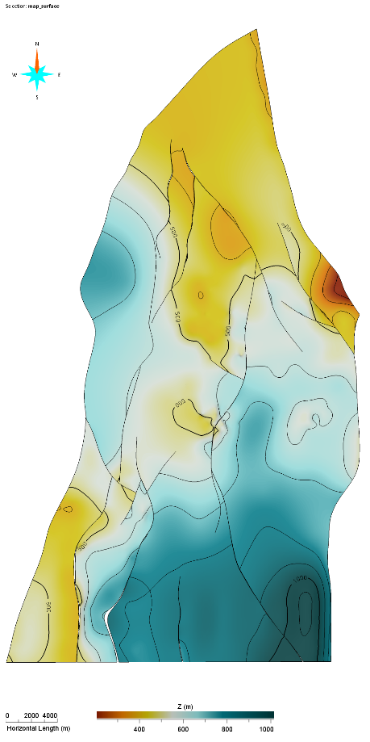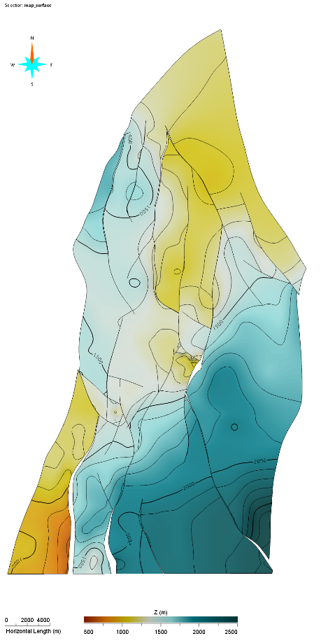

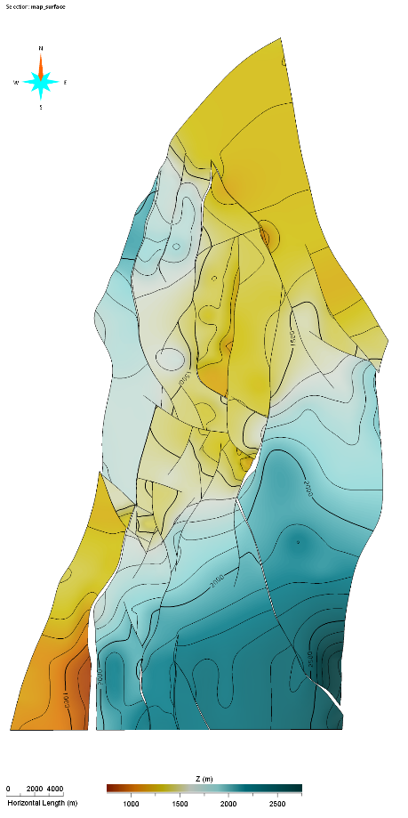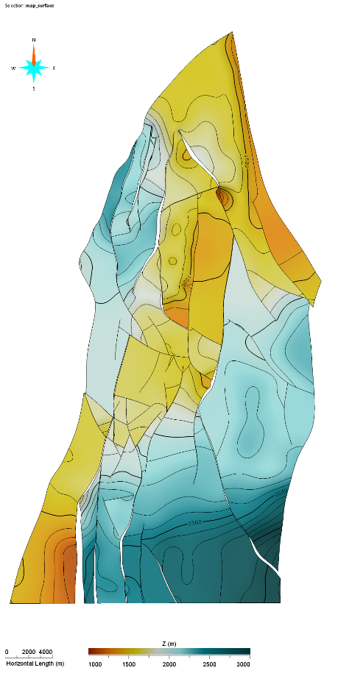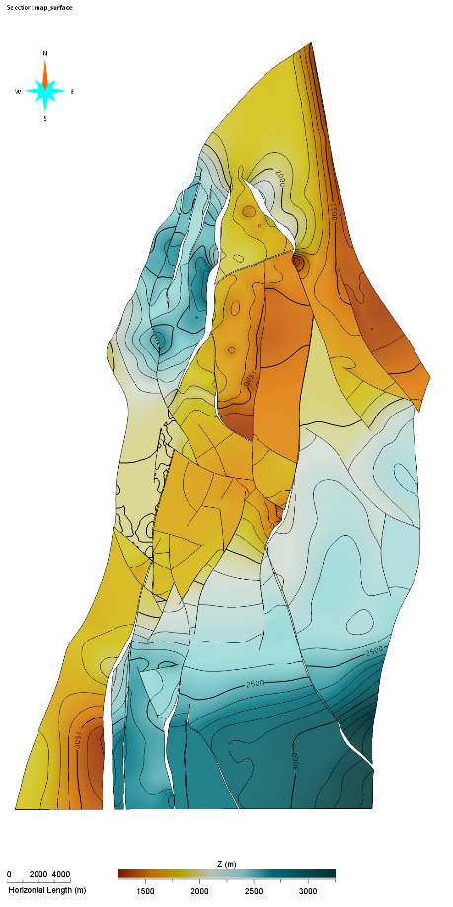

Figure 4: Depth maps of all model unit from upper left to lower right: Top Ried Group, Top Stockstadt Group, Top, Elsaß Subroup, Top Froidefontaine Subgroup, Top Pechelbronn Group, Base Pechelbronn Group. Please note the different depth legend for each model unit.

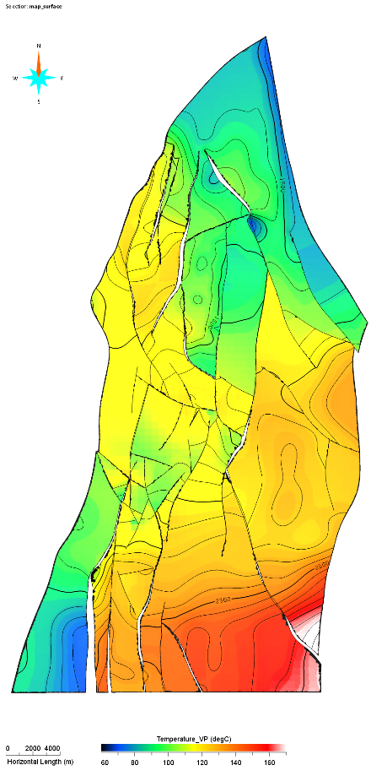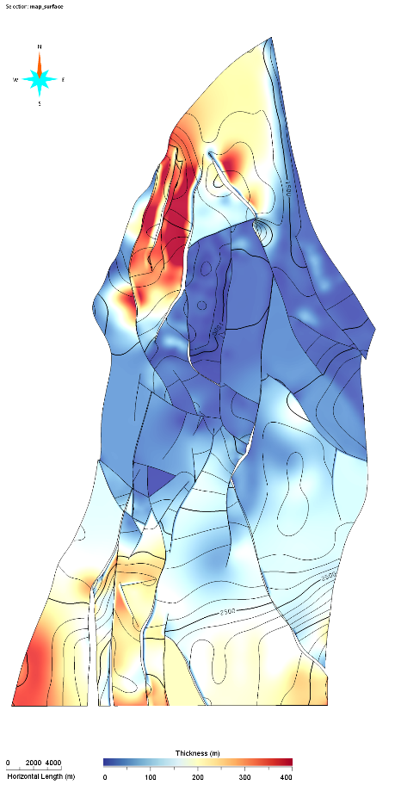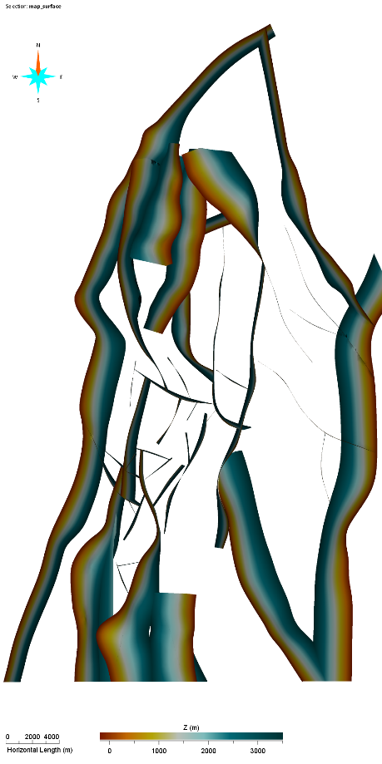

Figure 5: From left to right: temperature [°C] at the top of the Pechelbronn Group, thickness of the Pechelbronn group and all faults incorporated in the model.

The uncertainty of the structural model increases with increasing distance away from to the input data (Van der Vaart et al. 2021). For the horizon top surfaces, lithological well logs are the most trusted type of input data. Assessing the borehole locations (Figure 1), it becomes obvious that there are no drillings in the northern and southeastern parts of the study area. In the south, however, there is the reprocessed and recently reinterpreted DEKORP 9N 2D seismic section (Homuth et al. 2021) and the neighboring GeORG 3D model (GeORG-Projektteam 2013). For the key region of the geothermal potential assessment Eich-Königsgarten (Bär et al. 2022), the density of lithological well logs is high and a structural map based on 2D seismic surveys is available (Plein 1992), which implies less uncertainty concerning the structure, depth and thickness of the reservoir horizon.

For the fault planes, the 3D structural model of Hesse (Arndt 2012), the GeORG 3D model (GeORG-Projektteam 2013) and structural maps (Perner 2018, Derer 2003, Plein 1992, Illies 1974) served as input data. The exact location and course of a fault might differ by several hundred meters and the faults might be much less discrete than modelled here. We also neglected small faults with subseismic displacement. Reinhold et al. (2016) argue that published structural maps, which rely on 2D seismics, often display transfer faults and tend to overestimate fault lengths. In their 3D seismics, they do not observe transfer faults, but instead relay ramps. Since many of the faults in the inner graben used in our 3D model rely on the structural maps proposed by Perner (2018) (which were built using 2D and 3D seismics), we partly integrated newer interpretations based on 3D seismics. Especially in the surroundings of the region Eich-Königsgarten, where we modelled small, isolated compartments, the existence of relay ramps rather than transfer faults might imply that the compartments are not isolated and that the potential reservoir volume and interconnectivity is larger than anticipated in our study.

The degree of detail of the provided 3D structural model is relatively high because of the number of faults incorporated and considering it’s relatively large areal extend. Nevertheless, in a local scale model based on 3D seismic surveys, structural features could be resolved in greater detail, yielding more accurate information on the lateral reservoir extend.

# File description

The model horizons, fault surfaces and grids are provided in three different ways:

1) as tab separated ASCII files, one for each model unit while their structure is identical and

2) as GOCAD-SKUA objects (*surfaces*), which can be directly imported in GOCAD-SKUA projects and

3) as GOCAD-SKUA project, which includes all objects provided separately as described in 2.

As indicated by the headers of the ASCII files, column #1 contains the name, column #2 contains the part ID of the individual surface elements, column #3 contains the easting (X coordinate), column #4 the northing (Y coordinate), column #5 the depth of the top of the model unit [m above sea level]. The model horizontally extends by 27.5 x 49 km.

Depth information is provided for the irregular spaced grids which are unique for all model units. These grid nodes are assigned coordinates of the Gauß-Krüger DHDN Zone 3. The file names include the name of the corresponding model unit. The vertical resolution of the final 3D model is heterogeneous since it corresponds to the variable thickness of its units. For the GOCAD-SKUA objects, the properties as provided in the original project are giving additional information. As unique case, the SGRID of the Pechelbronn Group also provides the results of the stochastic hydrothermal potential assessment (Bär et al. 2022) as additional properties. The parameterized SGRID is provided within the GOCAD-SKUA project only (3), since the file size exceeds 30 Gb as ASCII or GOCAD-SKUA object.

Please also note that the thickness of the gridded units is set to 0.1 m at places where the units are observed to be absent. We accept this offset value since (i) this minor vertical shift of grid nodes significantly simplifies the transformation into a 3D model ready for applying the Finite Element Method (e.g., for heat transport simulations) and (ii) a thickness difference of 0.1 m does not critically affect regional-scale calculations of gravity anomalies and the conductive thermal field.

# Acknowledgement

The Federal Ministry for Economic Aﬀairs and Energy (BMWi) is gratefully acknowledged for funding the research project “Hessen-3D 2.0”, coordinated by the Technische Universität Darmstadt (grant agreement no. 0325944 A and 0325944 B). We kindly acknowledge our project partners and associated partners as the Helmholtz Center GeoForschungsZentrum Potsdam, the federal geological survey of Hessen (Hessisches Landesamt für Naturschutz, Umwelt und Geologie, HLNUG), the federal Ministry of Economics and Energy (Hessisches Ministerium für Wirtschaft, Energie, Verkehr und Landesentwicklung, HMWEVL) and the Leibniz Institute for Applied Geophysics (LIAG).

We want to thank the DFG in the framework of the Excellence Initiative, Darmstadt Graduate School of Excellence Energy Science and Engineering (GSC 1070) for their financial support.

The Bundesverband Erdgas, Erdöl und Geoenergie e.V. (BVEG) is kindly acknowledged for the collaboration agreement for data exchange. ExxonMobil and Wintershall Holding GmbH permitted access to its archive of drill cores and sampling, provided access to drill core data and to borehole geophysical logs.

# Contributions of each author

Meike Hintze: Conceptualization, Modelling, Data curation, Formal analysis, Investigation, Methodology, Visualization, Writing – original draft, review & editing

Dr. Kristian Bär: Conceptualization, Data curation, Funding acquisition, Project lead and administration, Supervision, Writing – original draft, review & editing

Dr. Judith Bott: Conceptualization, Funding acquisition, Writing – review & editing

Prof. Dr. Ingo Sass: Resources, Supervision, Writing – review & editing

# Competing Interest

We have no conflicts of interest to disclose.

# References

Arndt, D.: Geologische Strukturmodellierung von Hessen zur Bestimmung von Geopotenzialen, Dissertation, TU Darmstadt, Germany, 199 pp., 2012. <https://tuprints.ulb.tu-darmstadt.de/3082/>

Bär, K.: Untersuchung der tiefengeothermischen Potenziale von Hessen: Dissertation TU Darmstadt, 265 pp., 2012. <https://tuprints.ulb.tu-darmstadt.de/3067/>

Bär. K., Hintze, M., Bott, J., Sass, I. (2022, subm.): 3D model based assessment of the hydrothermal potential of the Pechelbronn Group in the northern Upper Rhine Graben, Germany. Submitted to Energy

Boigk, H.: Erdöl und Erdölgas in der Bundesrepublik Deutschland. – 330 S., Stuttgart (Schweizerbart), 1981.

Derer, C. E.: Tectono-Sedimentary Evolution of the Northern Upper Rhine Graben (Germany) with special regards to the early-synrift stage, Ph.D. thesis, Rheinische Friedrich-Wilhelm Universität Bonn, Germany, 103 pp., 2003. <https://hdl.handle.net/20.500.11811/1930>

Derer, C.E., Kosinowski, M., Luterbacher, H.-P., Schäfer, A. & Süß, M.P: Sedimentary response to tectonics in extensional basins: the Pechelbronn Beds (late Eocene to early Oligocene) in the northern Upper Rhine Graben, Germany. In: McCann, T & Saintot, A.: Tracing Tectonic Deformation Using the Sedimentary Record, Geological Society Special Publications, 208, 55-69, 2003. <https://doi.org/10.1144/GSL.SP.2003.208.01.03>

Derer, C.E., Schumacher, M.E. & Schäfer, A.: The northern Upper Rhine Graben: basin geometry and early syn-rift tectono-sedimentary evolution. In: Behrmann, J.H., Ziegler, P.A., Schmid, S.M., Heck, B. & Granet, M. (Eds.): EUCOR-URGENT Upper Rhine Graben Evolution and Neotectonics.- Int. J. Earth Sci. (Geol. Rundsch) 94: 640-656, Berlin, 2005. <https://doi.org/10.1007/s00531-005-0515-y>

Doebl, F.: The Tertiary and Pleistocene Sediments of the Northern and Central Part of the Upper Rhinegraben. - Abh. des Geol. L.-Amt B.-Württ. 6: 48-54, 1967.

Doebl, F. and Olbrecht, W.: An isobath map of the Tertiary base in the Rhinegraben. - In: Illies, J.H. & Fuchs, K. (Eds.): Approaches to Taphrogenesis: 71-72. Stuttgart (Schweizerbart), 1974.

Gaupp, R. and Nickel, B.: Die Pechelbronn-Schichten im Raum Eich-Stockstadt (Nördlicher Oberrheingraben; Blatt 6216 Gernsheim), Geol. Jb. Hessen, 128, 19–27, 2001.

GeORG-Projektteam: Geopotenziale des tieferen Untergrundes im Oberrheingraben, Fachlich-Technischer Abschlussbericht des INTERREG Projekts GeORG, Teil 1. – LGRB-Informationen, 28: 103 pp., Freiburg i. Br., 2013.

Grimm, K.I. and Grimm, M.C.: Geologischer Führer durch das Mainzer Tertiärbecken. – In: Grimm, K.I., Grimm, M.C., Neuffer, O. and Lutz, H. (Eds.): Die fossilen Wirbellosen des Mainzer Tertiärbeckens, Mainzer naturwiss. Archiv, 26, 7–32, 2003. <https://katalog.ub.uni-heidelberg.de/titel/68484816>

Grimm, M. C., Wielandt-Schuster, U., Hottenrott, M., Grimm, K.I., and Radtke, G. with contributions of Berger, J.-P. Ellwander, D. Harms, F.-J., Hoselmann, C., Picot, L., and Weidenfeller, M.: Regionalgeologische Darstellungen. – In: Deutsche Stratigraphische Kommission (Ed.): Stratigraphie von Deutschland IX. Tertiär, Teil I, Schriftenreihe der Deutschen Gesellschaft für Geowissenschaften, 75, 57–132, Hannover, 2011.

Hintze, M., Plasse, B., Bär, K., and Sass, I.: Preliminary studies for an integrated assessment of the hydrothermal potential of the Pechelbronn Group in the northern Upper Rhine Graben. Adv. Geosci., 45, 251–258, 2018. <https://doi.org/10.5194/adgeo-45-251-2018>

Homuth, B., Bär, K., Weinert, S., Stiller, M. (2021): Reprocessing of the Hessian DEKORP seismic profiles. 81. Jahrestagung der Deutschen Geophysikalischen Gesellschaft, Abstract-Nr.: A-122.

Illies, J.H.: Taphrogenesis and Plate Tectonics. - In: Illies, J.H. & Fuchs, K. (Eds.): Approaches to Taphrogenesis – Proceedings of an International Rift Symposium held in Karlsruhe in April, 13-15, 1972: 432-460, Stuttgart (Schweizerbart), 1974.

Kiefer, E.: Multi-method reservoir characterization in a sparse data exploration well: Example from the Northern Upper Rhine Graben. EEK Erdöl, Erdgas, Kohle, 2020. <https://doi.org/10.19225/200504>

Kött, A. and Kracht, M.: Möglichkeiten der CO2-Speicherung in tiefen Aquiferen Hessens. – In: Müller, C. and Reinhold, K. (Eds.): Geologische Charakterisierung tiefliegender Speicher- und Barrierehorizonte in Deutschland – Speicherkataster Deutschland, Schriftenreihe der Deutschen Gesellschaft für Geowissenschaften, 74, 165 – 187, Hannover, 2010.

Mauthe, G., Brink, H.-J., Burri, P.: Kohlenwasserstoffvorkommen und –potential im deutschen Teil des Oberrheingrabens. Bull. Ver. schweiz. Petroleum-Geol. u. –Ing., 60 (137), 15-29, 1993. <https://doi.org/10.5169/seals-216877>

Paradigm®: SKUA-GOCAD™ User Guide Part IX: Reservoir Modeling. 2013a.

Paradigm®: SKUA-GOCAD™ User Guide Part VIII: 3D Grid Building. 2013b.

Perner, M.: Evolution of Paleoenvironment, Kerogen Composition and Thermal History in the Cenozoic of the Northern Upper Rhine Graben, SW-Germany, Ph.D. thesis, Ruprecht-Karls-Universität Heidelberg, 222 pp., 2018.

Plein, E.: Das Erdölfeld Eich-Königsgarten. – Jber. Mitt. Oberrhein. Geol. Ver. N.F., 74: 41-54, 1992.

Reinecker, J., Hochschild, T., Kramls, M., Löschan, G., Kreuter, H.: Experiences and cahllenges in geothermal exploration in the upper rhine graben. European Geothermal Congress 2019, Den Haag, The Netherlands, 11 – 14 June 2019, 2019.

Reinhold, C., Schwarz, M., Bruss, D., Heesbeen, B., Perner, M., Suana, M.: The Northern Upper Rhine Graben – Re-dawn of a mature petroleum province? Swiss Bull. Angew. Geol., 21/2, 35-56, 2016. <https://doi.org/10.5169/seals-658196>

Rühaak, W., Bär, K., Sass, I.: Combining numerical modeling with geostatistical interpolation for an improved reservoir exploration. In: Energy Procedia, 59, 315-322, 2014. <https://doi.org/10.1016/j.egypro.2014.10.383>

Van Der Vaart, J., Bär, K., Frey, M., Reinecker, J., Sass, I.: Quantifying Model Uncertainty of a Geothermal 3D Model of the Cenozoic Deposits in the northern Upper Rhine Graben, Germany. Z. Dt. Ges. Geowiss. (J. Appl. Reg. Geol.), 172 (3), p. 365–379, 7 figs., 3 tables. <https://doi.org/10.1127/zdgg/2021/0286>. 2021.

Vidal, J. and Genter, A.: Overview of naturally permeable fractured reservoirs in the central and southern Upper Rhine Graben: Insights from geothermal wells, Geothermics, 74, 57–73, 2018. <https://doi.org/10.1016/j.geothermics.2018.02.003>